WORKPLACE CLOSE CONTACT INFORMATION
BEAUMONT HOSPITAL
You have been identified as a COVID -19 CLOSE CONTACT of a patient / staff member at work
- inform your manager of your status immediately
- follow the advice below
- Be aware of close contact public health advice and guidelines

Work advice:
Asymptomatic close contacts:
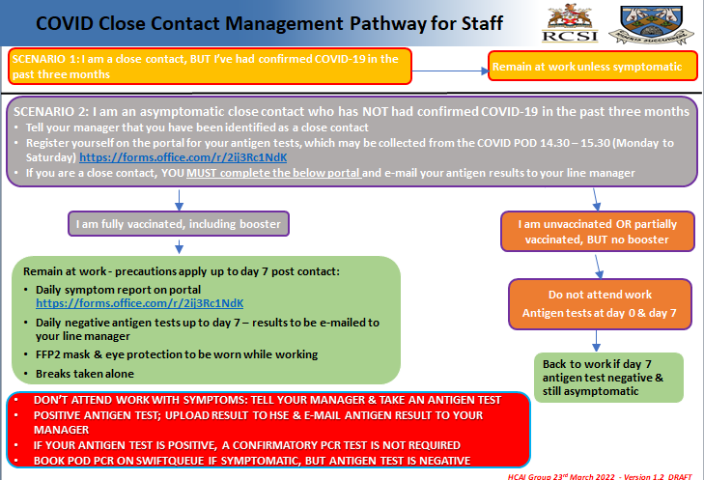
Symptomatic close contacts:
If you are symptomatic you cannot attend work. Please isolate and see information here. If your result comes back negative once your symptoms resolve and you are 48 hours well you can revert to the above algorithm.
Advice for life outside work:
Follow Public Health advice available here
Testing:
Register for antigen tests here
If you have a positive antigen:
- Notify Public Health here
- A confirmatory PCR test is not required.
- Please notify Contact Tracing of any workplace close contacts https://forms.office.com/r/1W6erajfYY

.

